Young Curators Programme at Stevenage Museum 2026
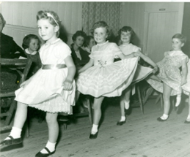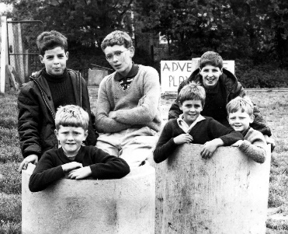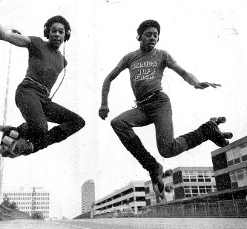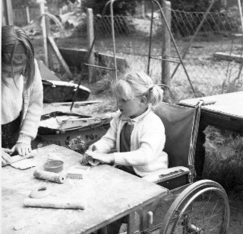
What is it
Stevenage Museum is inviting young people with an interest in heritage and museums to gain skills and hands-on experience in a museum environment. This programme will give our young curators the chance to work on projects that explore local history, and how museums tell these stories.
This year, the programme will focus on the 80th anniversary of Stevenage New Town, specifically on the theme of Growing Up in a New Town. Part of this project will be helping the museum to pull together an exhibition on this theme, choosing objects and helping us to tell these stories.
Who is it for?
14 – 18-year-olds with an interest in a museum career.
Commitment
The programme will run during term time, every other Thursday 4pm – 5:30pm
To ensure you get the most out of this programme, we are asking applicants to commit to a minimum of 10 sessions. This will make sure you can get fully involved with the activities, develop your skills and contribute to the project and exhibition. If you have specific availability concerns, feel free to reach out so we can discuss how best to accommodate your participation.
Dates
Term one | Thursday 10 September  Thursday 24 September  Thursday 1 October  Thursday 15 October  Half term 29 October  Thursday 12 November  Thursday 26 November  Thursday 10 December  Christmas break
Term two | Thursday 7 January  Thursday 21 January  Thursday 4 February  Half term 18 February  Thursday 4 March  Thursday 18 March  Easter holidays, end of project

Programme highlights
- Explore the museum’s store and objects not on display to help us pull together the Growing Up in a New Town exhibition
- Flex your writing and research skills
- Learn more about work in a museum and gain relevant skills
- Meet like-minded people
- There will also be the opportunity to visit other museums in the school holidays as part of this project.
A full programme will be sent to participants closer to the start date.

Application
Personal Information
Full name
Date of birth
Pronouns
Are you aged between 14 and 18?
Email address
Phone number

About you
Why are you interested in becoming a young curator? (200 words)

What interests you about the project, Growing Up in a New Town? (200 words)

Tell us why you think you’d be a great young curator (think about your skills, qualities and museum interests) (200 words)

Time commitment
This programme runs every other Thursday during term from September
2026 to the Easter break 2026, 4pm – 5:30pm

Are you able to commit to at least 10 out of 12 days?

This time commitment does not include additional trips taken within the school holidays. We will take into account exceptional circumstances.

Accessibility and support
Do you have any accessibility needs or require any additional support to take part in this programme? (e.g. sensory considerations, physical access requirements, or any other accommodations)

Additional information
Is there anything else you would like to share as part of your application?

Consent
By submitting this form I confirm that all the information provided is accurate and that I am between the ages of 14 and 18. I understand that my data will be used for the selection process of the Young Curators Programme.

I agree to the terms and conditions.
Applicant name
Signature

Parental/Guardian consent form for applicants under 18
Parent/Guardian name
Contact Number
Contact email
Signature

Email to: museum@stevenage.gov.uk
Or deliver a hard copy to: Stevenage Museum, underneath the church of St Andrew and St George, St George’s Way, Stevenage SG1 1XX

